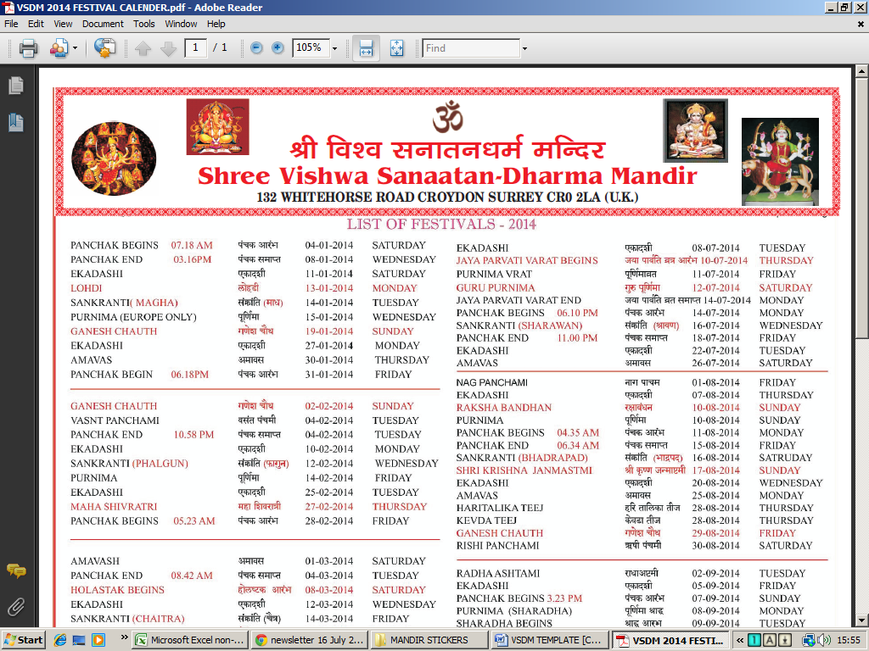
In Memory of Late Shree Parshotam Lal Bhagat Abbott & Late Smt Parvesh Bhagat Abbott



